 

**Placement Empowerment Program**

***Cloud Computing and DevOps Centre***

Host a Static Website Locally: Set Up a Local Server Apache and Host a Simple HTML page with your name

Name:Yasvanth Rajan E Department : AML



**Introduction and Overview**

In this Proof of Concept (POC), we will explore how to host a static website locally using the Apache HTTP Server. The process includes setting up a local web server, configuring it properly, and serving a basic HTML page. By following these steps, you will gain practical experience in configuring and running an Apache server locally—an essential skill for web hosting and server administration.

**Objective**

The goal of this project is to:

1. Set up a local web server using Apache.

2. Configure the server to host static files.

3. Create and host a simple HTML page displaying your name.

**Importance of Local Hosting**

Local hosting is a vital skill for developers, providing the ability to test and develop web applications in a controlled environment. It offers several key benefits, including:

* **Hands-On Learning**: Acquire practical experience in setting up and configuring servers.
* **Testing Ground**: Safely test, debug, and optimize websites before deploying them to a live server.
* **Offline Development**: Work on web projects without needing an active internet connection.

**Step-by-Step Overview**

Step1:

Search for "Apache Lounge" on Google and click the first link to access the official website. Click on the "Downloads" option located on the left-hand side of the Apache Lounge website.Click on the link Windows version, download the file, and extract all its contents.

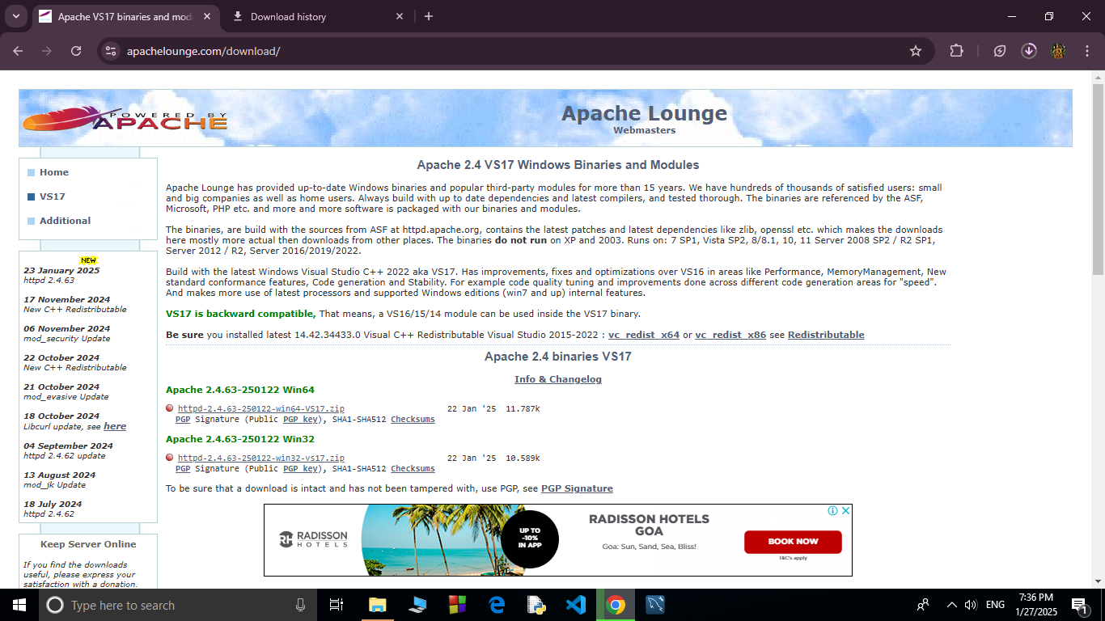

Step 2 :

Open Command Prompt as Administrator (Windows + R, type cmd, right-click and select 'Run as Administrator') and use the command cd C:\path\to\apache\bin to set the path to the Apache folder.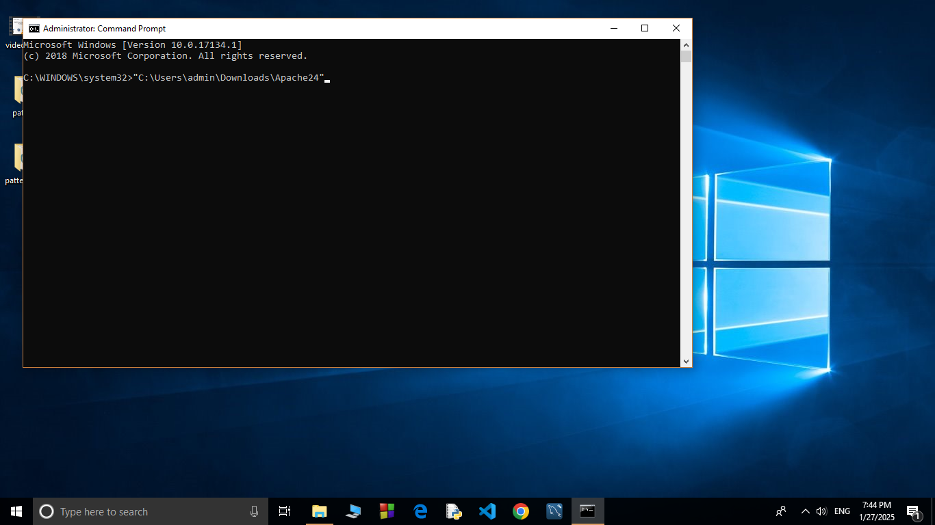

Step 3 :

Then Run the installation command :

**httpd.exe -k install**

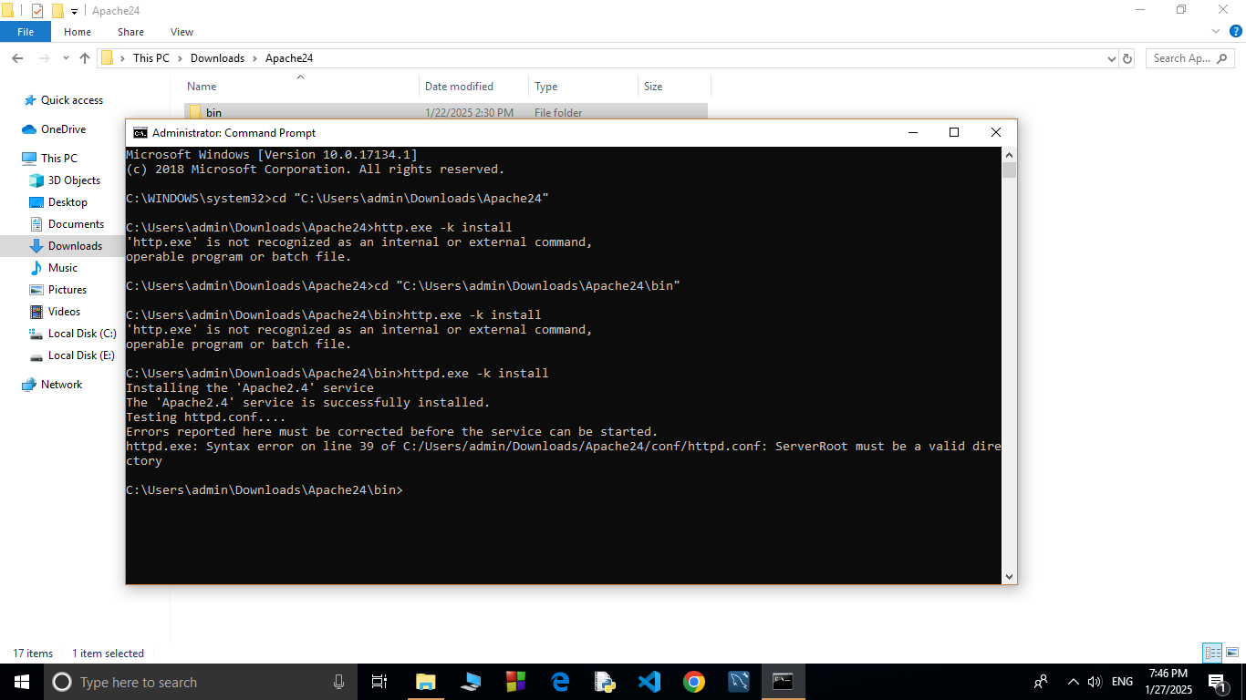

Step 4 :

Navigate to the Apache folder you downloaded, go to the **conf** folder, and right-click on the httpd.conf file; select 'Edit with Notepad'

(Apache/conf/httpd.conf)

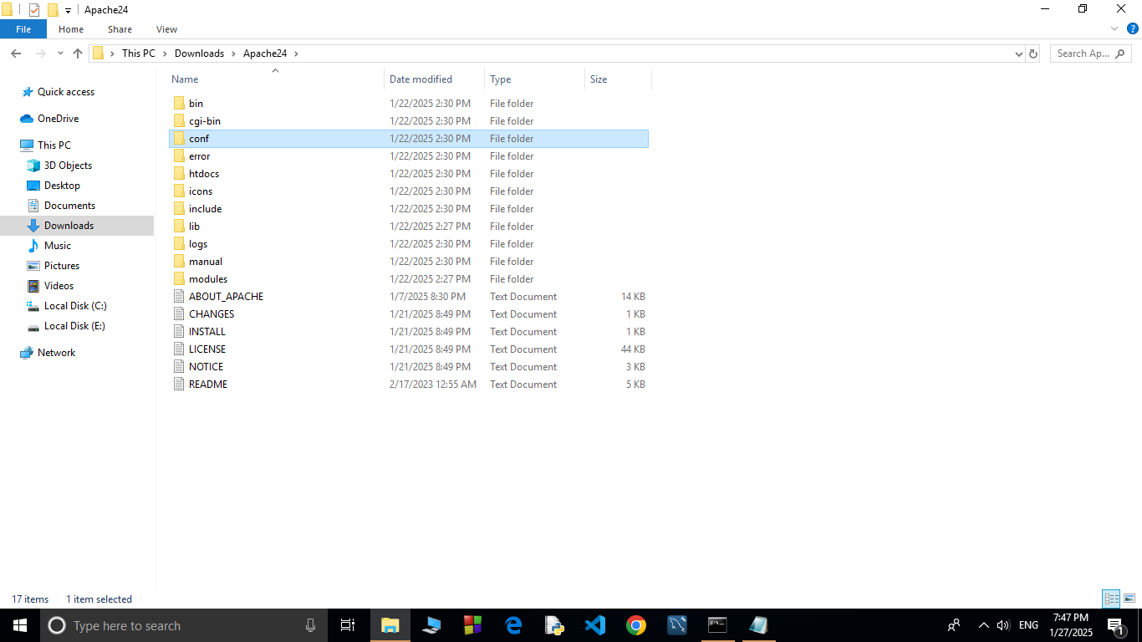

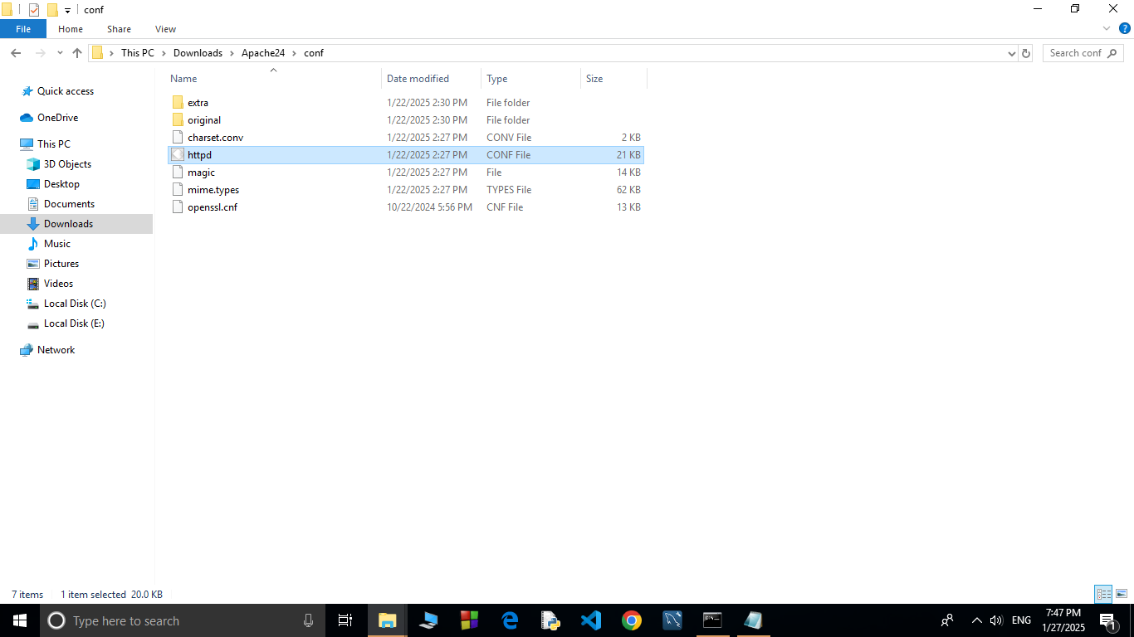

Step 5 :

Inside the **httpd.conf** file, replace the content with the provided configuration. Ensure you update the SRVROOT directive with your Apache installation path. This configuration defines the server’s root directory, listening port, modules, document root for serving web files, logging paths, and basic permissions, ensuring Apache serves content correctly from the specified htdocs directory.

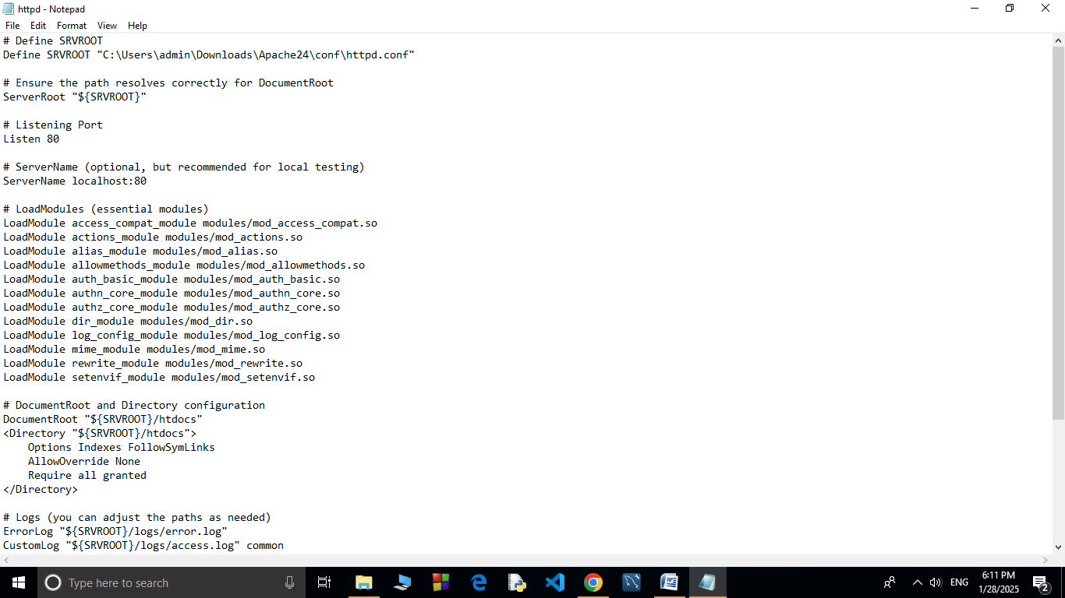

Step 6 :

Open Command Prompt and type the command **httpd.exe -t** to test the configuration file. If the configuration is correct, you should see **'Syntax OK**'.

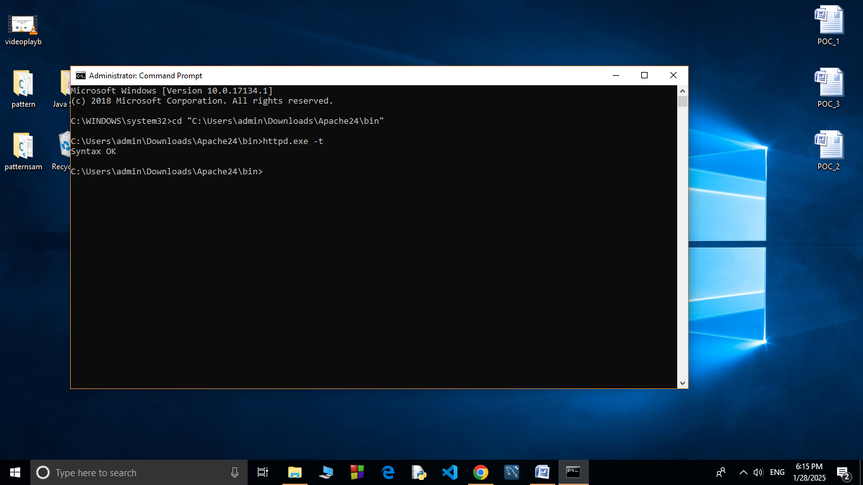

Step 7 :

Run the command **httpd.exe -k** start to start the Apache server.

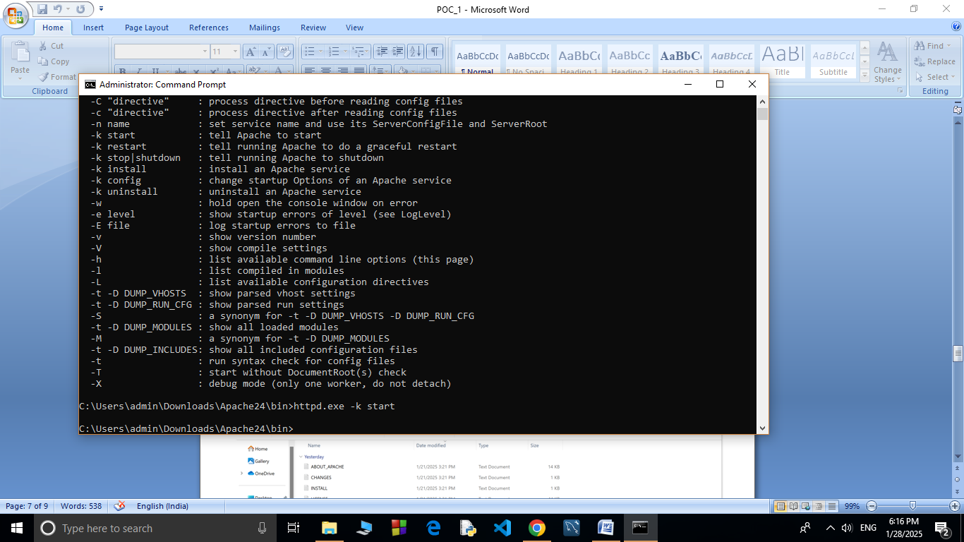

Step8:

Go to the Apache folder, navigate to the **htdocs** folder, and find the **index.html** file. Right-click on it and select 'Edit with Notepad'.

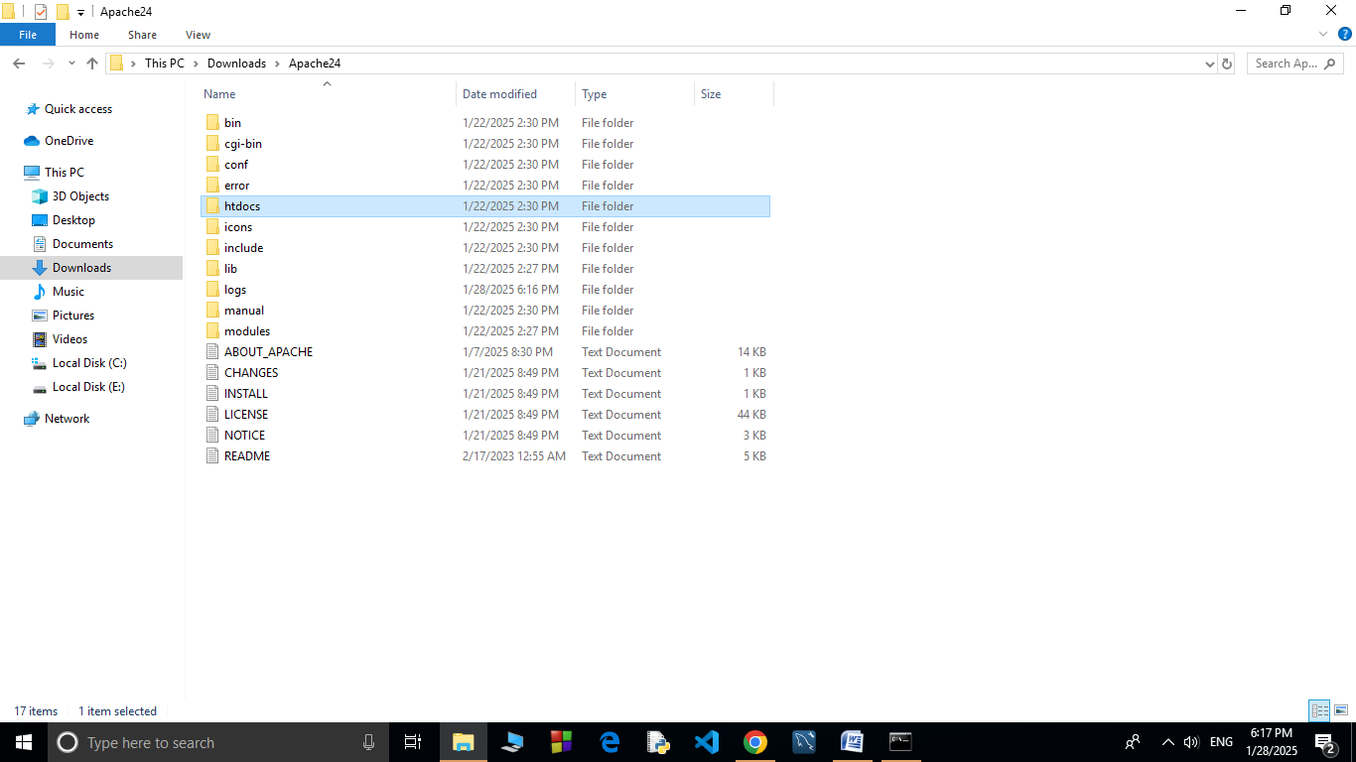

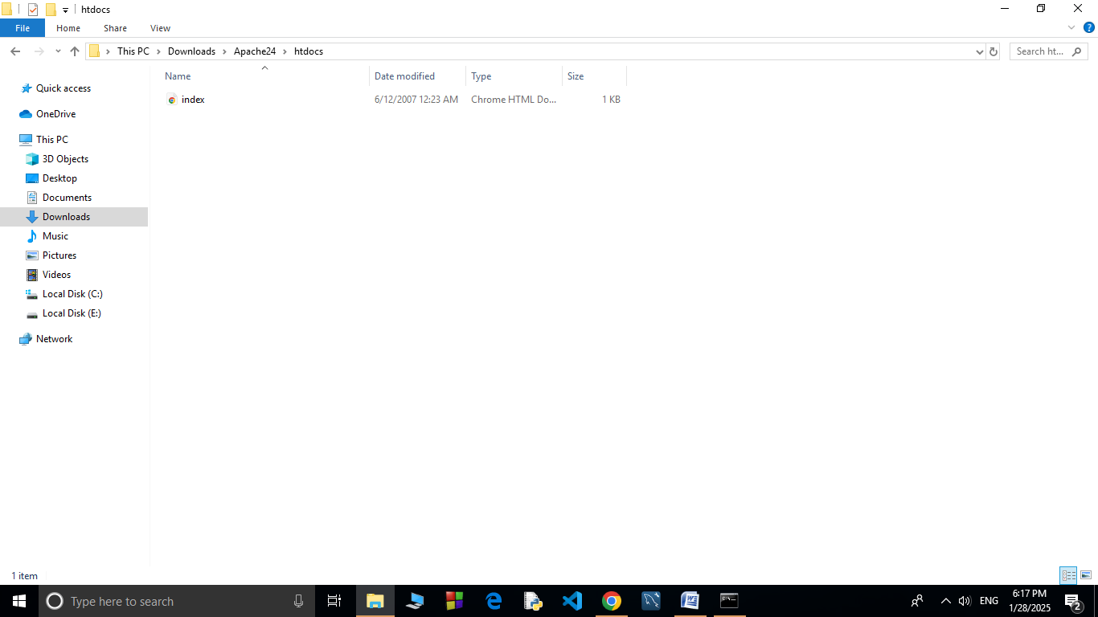

Step 9:

Create a simple model to display your name in HTML (you may optionally add CSS for styling).

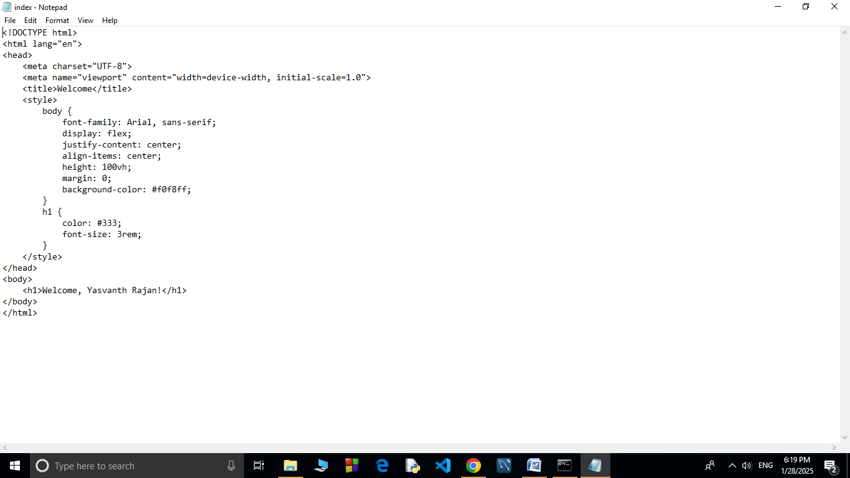

Step 11 :

Open the Chrome browser and type **localhost/index.html** in the address bar. You should be able to see the website hosted successfully.

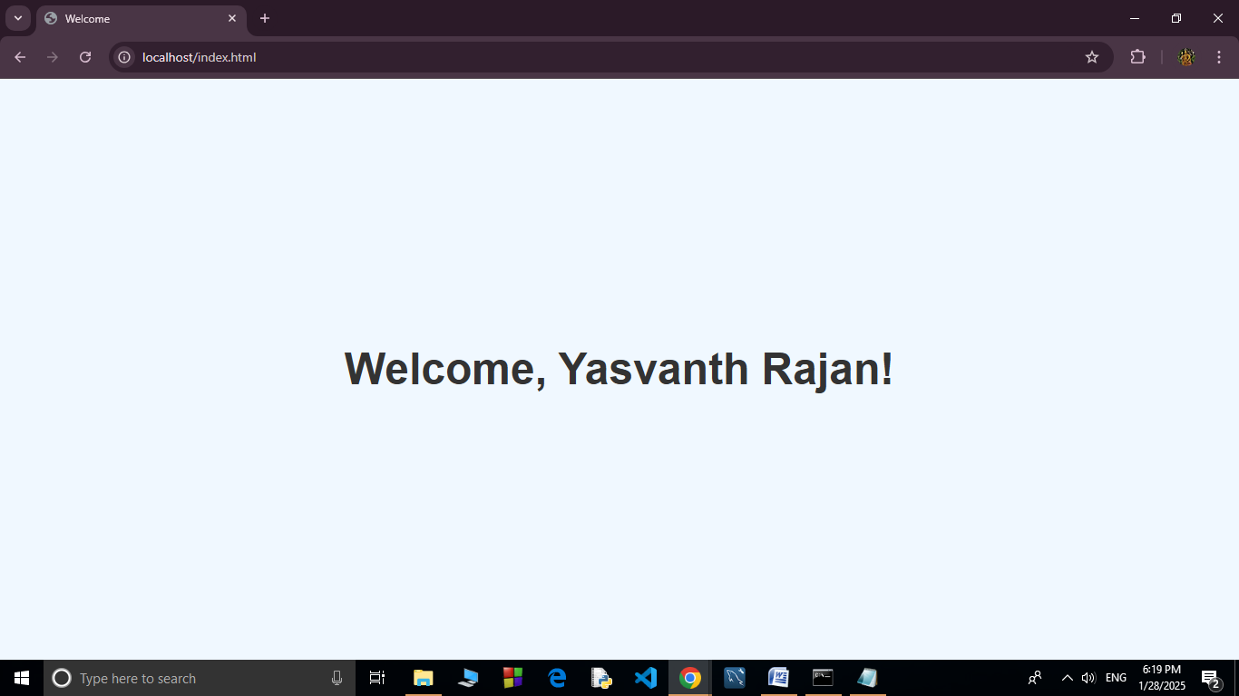

**Expected Outcome**

By completing this POC, you will:

1. Successfully configure and run an Apache server locally.

2. Host a static HTML website that displays your name.

3. Understand the basics of web server configuration and file hosting.